Name: Nabeel Ali

Student ID: 29005602

Email: [29005602@students.lincoln.ac.uk](mailto:29005602@students.lincoln.ac.uk)

Module: Neural Computing CMP9783M

**Section-1**

**Introduction**

Mathematical models of neuronal dynamics form a foundation of computational neuroscience. Out of these models, the leaky integrate-and-fire (LIF) and the adaptive exponential leaky integrate-and-fire (AELIF) are commonly used to model neuronal activity. These are reduced models that capture the essence of how the neuron responds to synaptic inputs and generates action potentials (spikes). The LIF model is based on a simple leaky membrane potential dynamics, while the AELIF implements adaptation mechanisms to obtain more realistic neural behaviors.

**Leaky Integrate-and-Fire (LIF) Model**

**Introduction**

The LIF model considers a neuron as an electrical circuit composed of a capacitor (the membrane) and a resistor (ion channels). A spike occurs when the membrane potential reaches a threshold and the potential resets. This simplicity renders the model an iconic instrument for characterising elementary neuronal dynamics.

**Parameters Explained**

*Membrane Capacitance (C_m):* Determines how fast the membrane potential change in response to current.

*Membrane Resistance (R_m):* Controls the membrane leakiness.

*Resting Potential (E_L):* The potential at which the neuron normally sits when inactive.

*Threshold Potential (V_th):* The potential which triggers a spike.

*Reset Potential (V_reset):* The voltage to which the membrane resets after a spike.

*Applied Current (I_app):* The input that causes the neuron to fire.

**Observations and Results**

Figure 1 - Basic LIF

**Part A:** Constant Current Pulse

Graph: The dotted line represents threshold current, where above threshold we see the periodic spiking in the membrane potential. The adaptation conductance is constant because adaptation is not implemented in the LIF model. (fig.2)

* The input current *(Iapp​)* is a step function that is applied from *t=0.5s to t=1.0s* with an amplitude of *500pA*.
* The input current equals zero outside this time window.
* This current serves as the driving force for the neuron to depolarize its membrane potential and fire spikes.
* The initial membrane potential *(V(t)=EL​=−75mV*.
* In this pulse *(t=0.5s to 1.0s),* the applied current causes the membrane potential to increase and spikes to be generated when the membrane potential crosses a threshold *(Vth​=−50mV).*
* After spiking, the membrane potential resets to *Vreset​=−80mV*, and the next spike takes slightly longer due to increasing adaptation conductance.
* The multiple firing rate decreases over the time of the pulse window representing the effect of adaptation.
* *GSRA​(t)* begins at zero.
* It rises after each spike by *ΔGSRA​=1nS* and decays exponentially with a time constant *τSRA*​=200ms.
* After the current is removed *(t=1.0s)*, the conductance will decay back to zero with no more spikes.
* The abrupt spikes trigger *GSRA*​ to increase repeatedly, while its exponential decay smooths out between the spikes.
* In general, the conductance rises slowly during the pulse of current.

Significance: This simple spiking behavior shows how neurons will integrate inputs over time and spike when those inputs exceed a threshold.

Figure 2- LIF with Adaptation

**Part B:** f-I Curve

Graph: Firing rate vs applied current, linear increase in firing rate with applied current shows linear aspect of input-output relationship Initial and steady-state firing rates overlap because there is no adaptation. (fig.3)

* Firing rate begins to increase as soon as applied current (*Iapp​*) exceeds a threshold (~0.2 nA).
* Here the line is an inverse to the first ISI, speed of which neuron to fire first in reaction to applied current.
* The firing rate of the first spike increases nearly linearly with the current applied.
* For high-applications currents *(Iapp​>0.5nA),* the firing rate is significantly above steady-state firing rate, showing a strong lack of immediate adaptation during the first spike.
* *GSRA*​: Since the firing rate during steady state period increases sub linearly with respect to initial firing rate due to adaptation.
* This line depicts the inverse of the steady-state ISI, obtained using the average ISI during the final second of the simulation
* At large current values, the steady-state firing rate saturates, indicating spike-rate adaptation.
* This results because *GSRA​* increases with each spike, diminishing the net driving force for spiking.

Significance: This illustrates that the LIF model is simple and thus has limited ability to reproduce complex neuronal firing patterns (adaptation, bursting).

Figure 3-LIF f-1 Curve

**Discussion**

The LIF model is a simplified model that highlights the basic principles of neuronal firing. This is especially useful for you to study simple integrative properties and network-level interactions. Its disadvantage lies in its lack of adaptive mechanisms, preventing accurate physiological results. Without adaptation, firing rates monotonically increase with current, which is not observed in real neurons.

The LIF Model Physiological Importance: The LIF model is appropriate for basic neuronal integration in sensory systems.

Pathological Relevance: Its ease of use makes it less suitable for diseases concerning lack of adaptation (e.g. epilepsy).

**Adaptive Exponential Leaky Integrate-and-Fire (AELIF) Model**

**Introduction**

The AELIF model is an extension of the LIF model that adds an exponential term to indicate the spike initiation and an adaptation term. The fast adaptation is an indicator of real neurons spike-frequency adaptation. Thus, the AELIF is a much more biophysically realistic model.

**Parameters Explained**

*Adaptation Time Constant (τ_SRA)*: Determines how fast the decay of adaptation goes over time.

*Spike-Triggered Adaptation (ΔG_SRA):* Positive change in conductance for adaptation after spike.

*Adaptation Reversal Potential (E_k):* The potential driving the adaptation current.

*Exponential Term (Δ_th):* Specifies the steepness of the spike initiation.

**Observations and Results**

Figure 4- AELIF with Adaptation

**Part A:** Constant Current Pulse

Graph: Membrane potential exhibits spike-frequency adaptation, with a decreasing rate of firing over time. Between each spike, the adaptation conductance decays, and it increases with every spike. (fig.4)

* At t=0.5s, a square current pulse of Iapp​=500pA is applied between t=0.5s and t=1.0s.
* The input current is zero except in this interval.
* Before the pulse (t<0.5s), the membrane potential stays at resting potential (EL​=−75mV).
* During the current pulse (0.5s≤t≤1.0s):
* The membrane potential increases and makes periodic spikes one time it surpass the threshold (Vth​=−50mV).
* After each spike, the potential resets to Vreset​=−80mV.
* After the current pulse ends (t>1.0s):
* ISRA​ decays to eventually bring the membrane potential back down towards the resting potential.
* There are no additional spikes, because the input current is zero.

Significance: The adaptation mechanism is more realistic neuronal behaviors like firing rate modulation in response to prolonged stimulation.

**Part B:** f-I Curve

Figure 5- AELIF f1-Curve

Graph: The initial firing rate rises steeply with current and the steady state firing rate saturates at high currents due to adaptation. (fig.5)

* This curve is the opposite of the steady-state ISI estimated in the last second of a simulation.
* The steady-state firing rate gradually increases with applied current and eventually saturates.
* It is composed of the inverse of the first ISI calculated from the first two spikes of each current level.
* It holds the neuron's most instantaneous response, prior to any adaptation.

Significance: It captures this real divided reluctance for firing resulting from topological pressures of input.

**Discussion**

The addition of adaptation allows the AELIF model to provide a closer approximation of biological neurons. This saturating behavior of steady-state firing rate emulates the refractory properties seen in biological neurons that prevent over-excitation.

Physiological Significance: The AELIF model is applicable to the study of cortical neurons, where adaptation is thought to dominate information processing.

Relevance to Pathology: It provides a model for disease with adaptation deficits, such as in multiple sclerosis or chronic pain conditions, in which neurons are hyperexcitable.

**Overall Discussion / Evaluation**

I compared the LIF models with AELIF, and this highlights the significance of both the adaptation in the dynamics of the neuron. The LIF model is computationally efficient and good for simple simulations, but its predictive power is limited since the AELIF model adds adaptation and exponential spike dynamics, making it more physiologically relevant.

Significance: The AELIF model is readily extendable to network simulations to probe emergent phenomena, such as synchronization, bursting, and oscillations.

These models can be improved to analyse real-life neurons networks by adding to them synaptic plasticity or dendritic dynamics.

**Section-2**

**Introduction**

**Hodgkin-Huxley Model as an Oscillator**

The Hodgkin-Huxley model provides insight into the ionic underpinnings of action potential initiation and propagation in neurons. It was proposed in 1952 by Hodgkin and Huxley, the framework delineates the voltage and time dependent dynamics of Na, K ion channels in response to membrane potential variations. Gating variables were introduced to represent channel activation and inactivation states. With broad applications, the Hodgkin-Huxley model enhance the understanding of diverse neural phenomena, including oscillatory behaviors, rhythmic firing patterns, and their disease-associated distortions.

Conceptualizing the Hodgkin-Huxley framework as an oscillator allows exploration of how extrinsic currents impact oscillatory membrane properties. Such dynamics play critical roles in normal processes such as signal transfer, synchronization, and rhythm generation throughout the nervous system. Disruptions in oscillatory function also relate to pathological conditions like epilepsy and arrhythmias. The model's implementation as an oscillator furnishes novel insight into influences on oscillatory neuronal membrane properties and their associations with health and disease.

Equation 1- HH model Setup

**Observations and Results**

Table 1- Parameters

Table 2- Gating Variables

**1. Baseline and Transient Dynamics**

This segment relates to Question 1, where the standard behavior of the Hodgkin-Huxley design without exterior disturbances is investigated.

Figure 6- Hodgkin Huxley

**Graph Analysis:**

* The stationary membrane potential was witnessed at approximately -70 mV, settling under baseline situations without external perturbation.
* Minuscule oscillations in the membrane potential occurred briefly before achieving a steady state value owing to the intrinsic ionic currents balancing one another.

**Parameter Explanation:**

* **Baseline current:** Maintains the original steady state of the neuron.
* **Leak conductance :** Accounts the passive ion flow, stabilizing the resting potential.
* **Capacitance :** Determine the rate of membrane potential in reply to ionic currents.

**Significance:** This steady state behavior spotlights the models ability to actually mimic the physiological resting potential of neurons and illustrates stability under minimal/no external stimulation.

**2. Response to Step Current**

This segment relates to Question 2, where step current is used to analyse the impact on membrane potential.

Figure 7- Step Current Response

**Graph Analysis:**

* The applied current graph clearly shows a step input abruptly introduced at 100ms and steadfastly maintained until 200ms had passed.
* The membrane potential reacted to this change with a gradual yet unrelenting depolarization as the current was applied, stabilizing once more after the forced removal of the imposed current.

**Parameter Explanation:**

* **Step current amplitude:** It plays a crucial role sustaining depolarization throughtout the specific step duration.
* **Membrane potential stabilization:** It shows the balancing in between Na, K current following external input.

**Significance:** This demonstration tells how enduring shoved currents can impact neuronal excitability and the membranes drive to find equilibrium once more, fundamentals critical to comprehending neural responses when stimulated at fixed rate.

**3. Oscillatory Dynamics with Pulsed Input**

This segment tells us about Question 3, wherein the impact of pulsed currents with distinct separations (15 ms and 25 ms) is analysed.

Figure 8- Pulsed Currents

**Graph Analysis:**

* Pulses separated by varying intervals induced unique oscillatory reactions in neurons. With a shorter gap of 15ms between successive depolarizations, the membrane potential fluctuated rhythmically below spike threshold in a subthreshold oscillation.
* Lengthening delays to 25ms allowed more recuperation between pulses, further stabilizing/controlling the subthreshold oscillations.

**Parameter Explanation:**

* **Pulse amplitude and duration:** It drives transient activations.
* **Recovery time:** Regulates the accumulation and interaction of oscillatory activations.

**Significance:** The oscillatory behavior demonstrates the Hodgkin-Huxley models aptitude to simulate repetitive, rhythmic firings critical for signal encoding and synchronization. Physiologically, this symbolises oscillatory neuronal activity observed in the processes such as respiration and circadian rhythms where harmonized activations are important.

**4. Inhibitory Pulses and Recovery Dynamics**

This section details ques 4, examining the effects of inhibitory pulses on membrane potential.

Figure 9- With Inhibitory Pulses

**Graph Analysis:**

* The above current graph shows inhibitory impulses of 5ms recurring every 20ms.
* At first, the membrane potential oscillates subthreshold with dips matching each inhibitory signal. Eventually, it attains equilibrium.

**Significance:** Inhibitory inputs manage excitability and prevent overactivation, modeling standard neuronal behavior. Pathologically weakened brakes on inhibition it could potentially result in a hyperexcitable condition like seizures.

**5. Excitatory Current and Action Potential Generation**

This portion relates to Question 5, where an excitatory stimulus was aligned to analyse its impact on membrane potential.

Figure 10- With Excitatory Pulse

**Graph Analysis:**

* The implemented current illustration shows a baseline current of 0.65 nA with a 1 nA excitatory pulse applied at 100 ms for 5 ms.
* The membrane potential graph demonstrates depolarization owing to the excitatory pulse, generating an action potential followed by gradual repolarization.

**Significance:** Notably, this exhibits the model's capacity to recreate action potential formation, essential for neural interconnection. Pathologically, altered excitatory responses could represent hyperexcitability in conditions such as epilepsy.

**6. Effect of Higher Baseline Current**

This section examines question 6 a simulation with a raised baseline current (0.7 nA ) and an excitatory pulse of 1nA at the time 100ms for 5ms.

Figure 11- Higher baseline Current

**Graph Analysis:**

* The applied current graph demonstrates the heightened resting potential due to the elevated baseline. A brief surge in current is delivered midway through.
* The membrane potential diagram indicates a notably more pronounced peak action potential compared to the previous scenario (que 5). The spike threshold has reduced owing to the pre existing depolarization.

**Significance:** Baseline current shifting resting potential closer to the threshold that can emulate persistent excitement under pathological conditions like chronic pain or seizures. Larger peak result from a decreased threshold following chronic depolarization.

**Discussion**

**Oscillatory Behavior**

Under certain parameters, the Hodgkin-Huxley model endogenously spawns oscillatory behavior emerging from sodium and potassium currents interacting. Oscillations are influenced by external stimuli, recovery kinetics, and intrinsic channel properties, crucially underpinning locomotion, breathing, and circadian rhythms. Irrelevant oscillations relate to epilepsy, Parkinson's disease, and cardiac arrhythmias.

**Physiological and Pathological Significance**

1. **Physiological:**
   * Action potentials and oscillations that are explored here are indispensable for neural circuitrys data processing, synchronization, and timing ability. Subthreshold rhythm subserve pacemaking in neurons and smooth muscles.
2. **Pathological:**
   * Hypersensitivity producing excessive firing can actually mimic epilepsy, neuropathic suffering. Impaired repolarization, as seen in the oscillatory model, could connect to arrhythmias of heart.

**References**

1. Hodgkin, A. L., & Huxley, A. F. (1952). A quantitative description of membrane current and its application to conduction and excitation in nerve. *The Journal of Physiology*, 117(4), 500-544.
2. Izhikevich, E. M. (2007). *Dynamical Systems in Neuroscience: The Geometry of Excitability and Bursting*. MIT Press.
3. Koch, C. (1999). *Biophysics of Computation: Information Processing in Single Neurons*. Oxford University Press.
4. Kandel, E. R., Schwartz, J. H., & Jessell, T. M. (2000). *Principles of Neural Science*. McGraw-Hill.
5. Brette, R., & Gerstner, W. (2005). Adaptive exponential integrate-and-fire model.
6. Gerstner, W., & Kistler, W. M. (2002). Spiking neuron models.

**Appendix.**

* 1. **Basic LIF model**

**LIF part A**

**LIF Part B**

**Basis AELIF**

**AELIF part A**

**AELIF part B**

**Hodgkin Huxley Model**

**The changes in 2nd Question  
**

**The changes in 3rd Question**

**The changes in 4th Question**

**Changes in 5th Question**

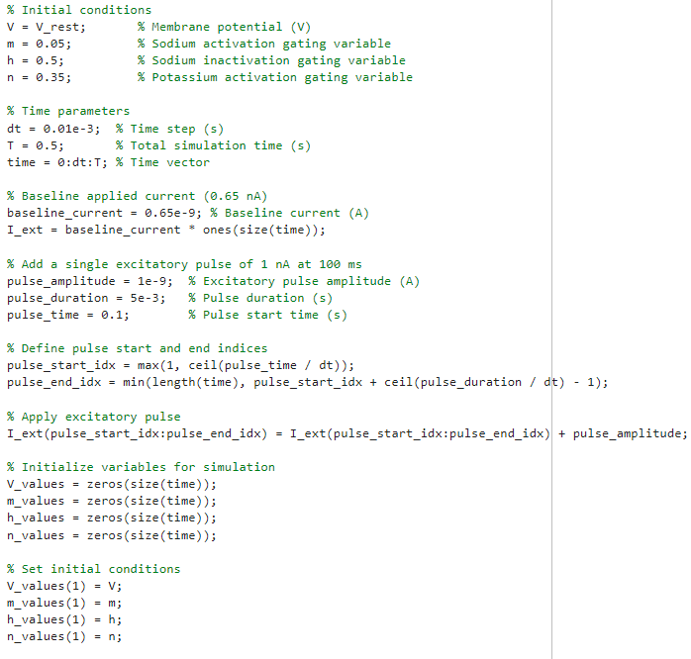

**Question 5 Simulation Loop**

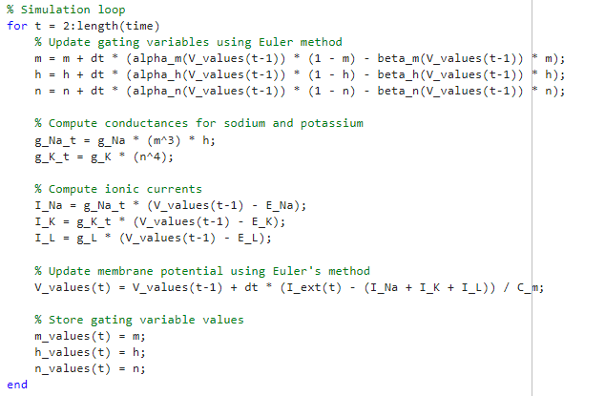

**Question 6, Simulation loop is same as question 5.**

